**TEXT TO SPEECH USING AWS POLLY**

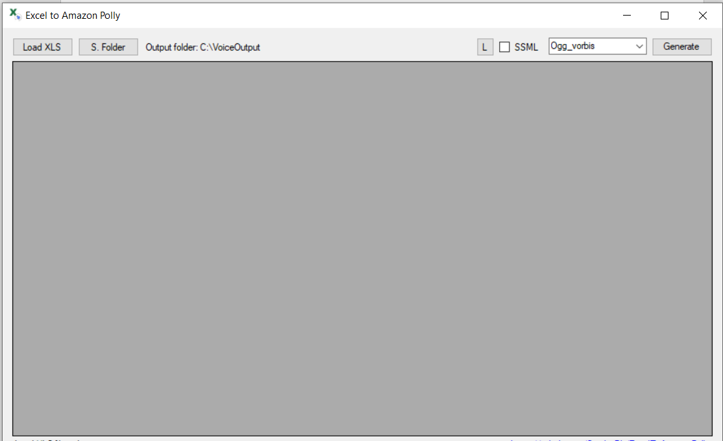

Fig 1

Figure 1 is the home screen page of the application. On clicking The “Load XLS” button, it opens a dialogue box from where you need to browse and select the xls file that you need to use in AWS Polly. “S. Folder” shows you where to store the output audio file. “L” is list of available lexicons. You need to go to AWS Console to manage lexicons. SSML stands for “Speech Synthesis Mark up language”. You need to mark the checkbox if you want to use SSML. The next dropdown contains list of output file format. JSON, MP3, pcm(raw file format for storing digital audio), ogg_vorgis(open source patent-free audio compression format) are the formats which you can have your output.

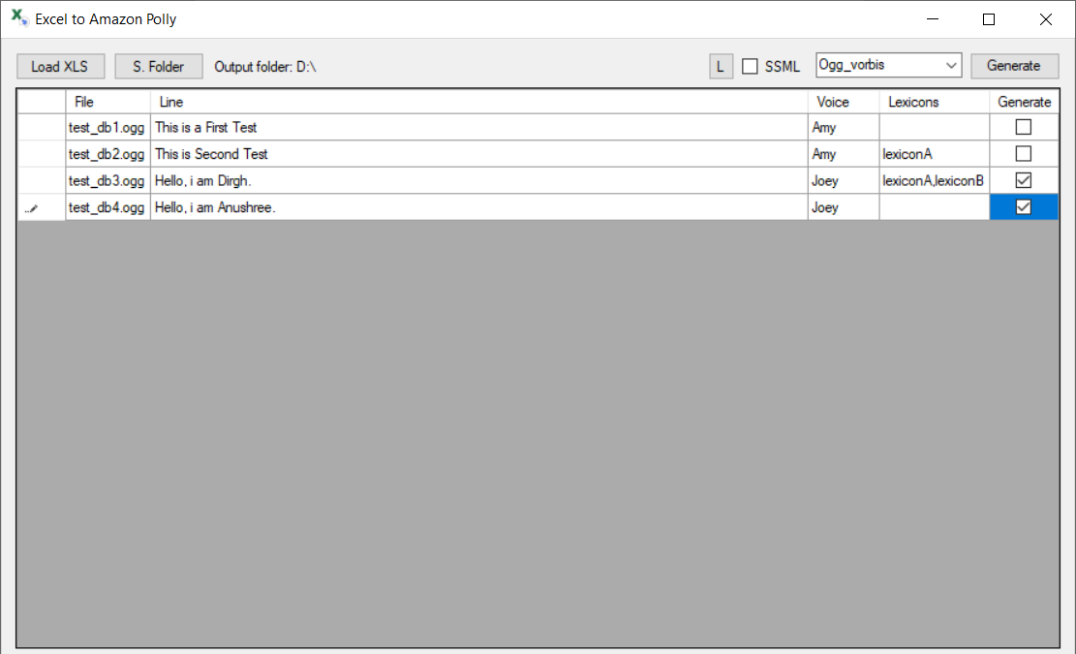

Fig 2

Figure 2 shows that we loaded the file called “voice_list_examples”. The second column shows the file nme that would be there after the generation of the audio file. Third column contains the Line/ Text that we need to convert into audio. The next columns has the list of voices which we need to use to convert the text to audio. We need to select a voice to be used in the conversion. There is a column for lexicons that we can use if e want to. As you can see, we have used Lexicon A and Lexicon A, Lexicon B in few of conversion. Lastly, there is a checkbox need to marked if we want that file as an output file in any of the format. Once you set all the column values, You are ready to press the Generate Button.

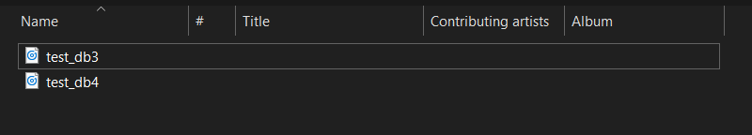

Fig 3

On clicking the generate button, the application will process and we would get the output files in selected file format in those files which we marked the checkbox to generate files as you can see in figure 3.

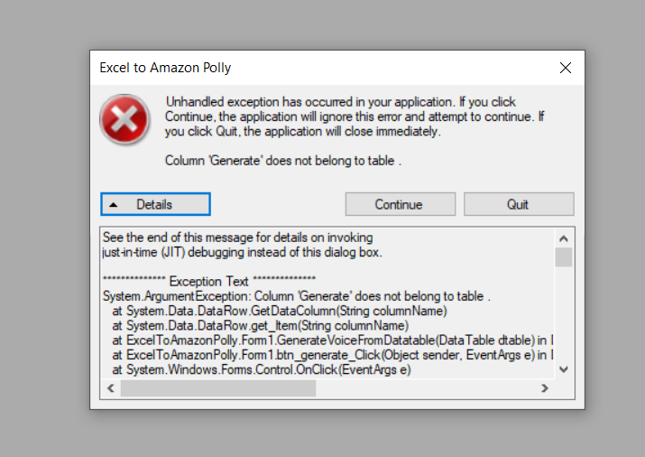

Fig 4

If there is any kind of error while procession, an error message is displayed. If you upload the wrong formatted excel file or empty file or in few other scenario, error message is generated. We have also provided the details button where you can see the error details. You can try to resolve the error by looking into the details of error.